Setting Up an N-tier NetOxygen All-In-One Server

Division/Group | Owner/Author  Michael Lawson / Tery Hopkinson | Prepared By  Deborah Holmes | Doc Status | Revised Date  06/02/2006

The QA, Production, Certification, and Training environments are installed on stand-alone servers.
All-In-One Server System Requirements
- Windows Server 2003
- Internet Information Services 6.0 (IIS)
- Soap Toolkit 3.0 (included on installation CD – 3rd Party Directory)
- Adobe Acrobat Reader 7.0 (installed separately)
- Internet Explorer 6.0
- NetOxygen v2.4.1 Install Executable
- Administrative Rights on the destination server
Work Instruction
Procedure: Configure a New DSN on the All-In-One Server
Step | Action | Screen Shot / Comments
1 | Launch the ODBC System Administrator located in the Administrative Tools folder on the Start Menu. | Setting up the DSN first on the All-In-One Server ensures that the Server being configured has the necessary communication to the Database Server prior to initiating any other part of the installation.
2 | Select the System DSN tab and click on the Add button to add a new system DSN.
3 | On the Add New Data Source screen, select SQL Server.
4 | Click Finish. The Create a New Data Source to SQL Server screen opens.
5 | Enter the following information; click Next to continue. | - Name: NETOX  - Description: leave blank  SQL Server: [HSBCDB01]
6 | Select the With SQL Server Authentication using a login ID and password entered by the user radio button. | - Click the Client Configuration button; specify the 49571 port; click OK to close the sub-dialog.  - Enter the appropriate Login ID:GFSMORT and Password: mortgage to access the NETOX database.  Click Next to continue.
7 | Verify the default database is the NETOX database; click Next to continue.
8 | Select the Change the language of SQL Server system messages to: checkbox; select English from the drop-down list box; click Finish to continue.
9 | Click the Test Data Source button on the Overview pop-up dialog to verify the new DSN can communicate with the Database; click OK to continue.
10 | The DSN for the NETOX database has now been successfully created.
11 | Repeat steps 1-8 above to create the NOA DSN connection specifying the NOA credentials.  The default DB shown should be NOA.  Once both DSNs have been successfully created and tested, you can move onto Base Application Server Installation. | - Enter the appropriate Login ID: NOA and Password: noa to access the NETOX database.

Procedure: Base All-In-One Server Installation
Step | Action | Screen Shot / Notes
1 | Locate and copy the NetOxygen v2.4.1InstallShield executable to a local drive on the All-In-One server.  Ensure you are logged in as the Domain Administrator.
2 | Double-click on the NetOxygen v2.4.1InstallShield executable to begin the base application install.
3 | When prompted to install J# (J Sharp) v1.1, select YES. | Accept all defaults in the J# installer
4 | When prompted for Username and Company, enter the following: | Username: Fremont User  - Company: Fremont Investment & Loan
5 | When prompted for the installation location, change the location to D:\<default install path>.
6 | When prompted to select components for install, select all components and sub-components. | 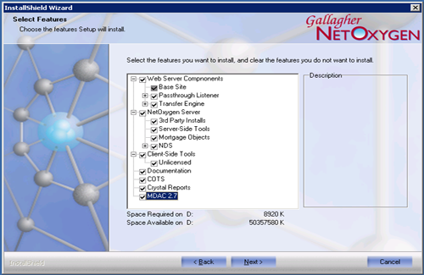
7 | When prompted to install VB Script documentation, select NO.
8 | When prompted to install Sentinel Drivers, select NO.
9 | After the NetOxygen v2.4.1InstallShield finishes, reboot if prompted to  When the server reboots, the base un-configured application is installed. | Note: Generally the installer prompts you to reboot if it doesn’t it is strongly recommended that you reboot the server at this time.

Procedure: Apply Fremont Customizations to N-Tier All-In-One Server

Step | Action | Screen Shot (if applicable)
1 | To restore a NetOxygen Reference Backup to a NetOxygen Server using the GUI mode, proceed as follows:  Start the NetOxygen Backup and Restore Utility under the Tools folder inside the Migration folder. To start the utility, double-click on the NetOxBkupRestore3.0.exe file.  Once started, the utility displays a series of dialogs requesting specific information required to restore a NetOxygen Server.  The NetOxBkupRestore v 3.0 – Welcome screen appears telling you what the utility is. | 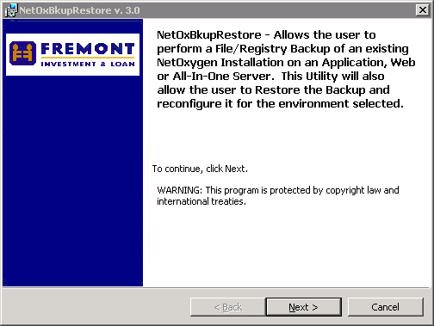
2 | Click Next when you are ready to proceed. The NetOxBkupRestore v. 3.0 – Backup/Restore/Configure Options dialog appears allowing the user to tell the utility what it wants to accomplish. | 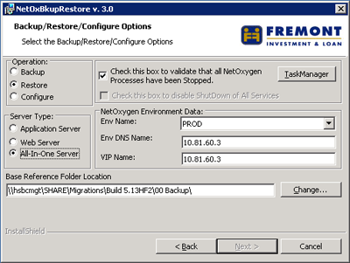
2a | Choose the Operation you want to perform first.  Select the Restore radio button option under Operation. Then, select the Server Type to perform this operation on:  All-In-One Server – NetOxygen Installation that combines the Application and Web Servers.
3   | After selecting the Server Type, you need to validate that all NetOxygen processes have been stopped.  Click the TaskManager button to start the Windows Task Manager. In Task Manager, click the Processes tab and verify that no NetOxygen Processes are still running.  Once you have verified that no NetOxygen processes are running, select the Check this box to validate that all NetOxygen Processes have been Stopped checkbox.  You MUST check this box to proceed.
4 | Next, select the NetOxygen Environment Data. There are three possible entries depending on the Server Type you selected. Only those required are available for selection or entry of data. First, select the Environment Name from the drop-down box PROD  Next, enter the Environment DNS Name or the name of the server that is hosting the NetOxygen logon page. 10.81.60.3  If you are restoring an All-In-One Server, you will be prompted to enter the VIP Name, 10.81.60.3
5 | Enter the Base Reference Folder Location. This is the base folder that contains the backup folder you want to restore.  If you use the default folder, D:\NetOx_Reference, then the backup folder you wish to restore should be at this location.  If you want to use another base folder, type in this folder or click the Change button and select the appropriate base reference folder.  Once you have completed entering all information, click Next to continue.  The NetOxBkupRestore v. 3.0 – Reference Folder Options dialog appears.
6   | Based on the Server Type selected, the restore utility generates a list of appropriate reference folders and displays them in the All-In-One Server Reference Folder dropdown box as shown in the previous step.  If you have chosen to restore an All-In-One Server, the dialog box appears similar to the one shown here.  You have the option to separate web and application server reference folders. | 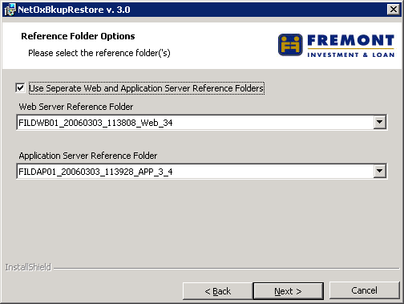
7 | Select the Use Separate Web and Application Server Reference Folders checkbox, a dialog box similar to the one shown displays the available reference folders listed in the appropriate drop-down boxes.
8   | After selecting the reference folder(s) to be restored, click Next to continue.  The NetOxBkupRestore v. 3.0 – Remove existing NetOxygen Folder Selection dialog appears. This dialog box serves as a reminder that during the restore process, the NetOxygen Folder is completely deleted and then restored from the reference folder.  If there are files the user wanted to save, select the Do Not Remove Existing Folder – Abort Restore radio button and click Next to abort. | 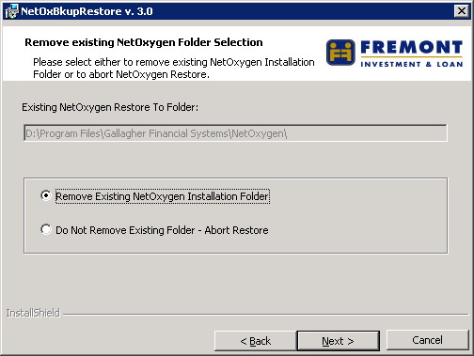
9 | Select the Remove Existing NetOxygen Installation Folder radio button when you are ready to continue, click Next to proceed.  The NetOxBkupRestore v. 3.0 –Ready to restore NetOxygen Reference Folder dialog appears.  Validate that the information displayed is correct for the Server you are restoring. If any information is incorrect, click the Back button to return to prior dialogs and fix the appropriate entries. Once you are satisfied with your selections, click the Restore button to begin the restore procedure. | 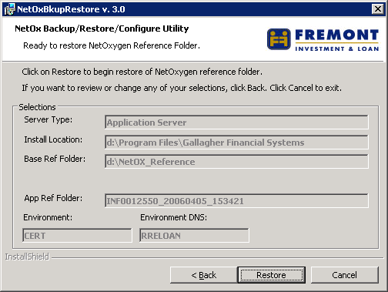
10 | During the restore procedure there will be various dialogs displayed to let you know where the utility is in the restore process.  If the utility encounters an Error while performing the restore procedure a message box dialog similar to the one show appears explaining the error. The error message is also written to the Restore Log file.  If the restore procedure fails to complete, click the OK button. | 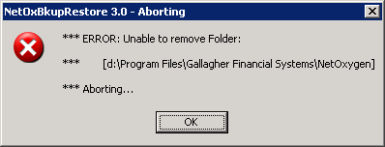
10a | The NetOxBkupRestore v. 3.0 – Failure message box appears. Again, click the OK button to Abort the Restore and then review the log file to determine what happened.  Correct the error and restart the restore. | 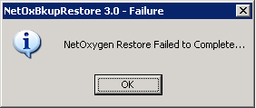
11 | Once the restore has completed successfully, the NetOxBkupRestore v. 3.0 – Success message box appears.  Click OK to continue. | 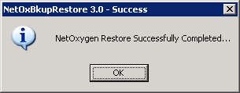
12 | The restore utility displays the restore log file in Notepad as shown here.  An example of the log file is included in the Attachments section at the end of this document.  It is highly recommended that you review the log file carefully to ensure that the restore of the NetOxygen Reference Folder completed successfully.  After you have finished reviewing the log file you MUST close Notepad to Continue.  Search for error- | 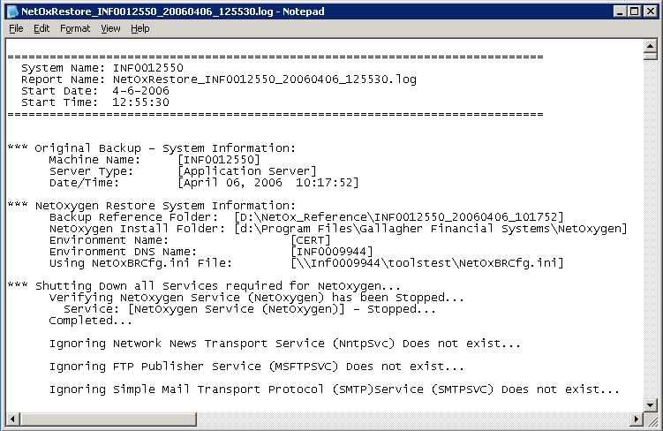
13 | Close Notepad. The NetOxBkupRestore v. 3.0 - System Reboot message box appears prompting you to reboot your system. | 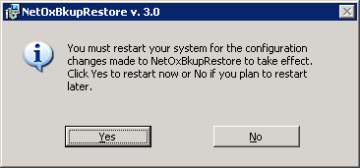
14 | Click Yes to reboot your system.  You must reboot the computer to complete the Restore of the NetOxygen Reference Backup.  After the Server reboots, complete your validation procedures to ensure that the Restored Environment is functioning properly.

Procedure: Configure the Fremont Customized NetOxygen N-Tier All-In-One Server
Step | Action | Screen Shot / Notes
1 | Launch the IIS Services Manager Console.
2 | Fremont has opted to add the additional steps of removing the pre-installed directories and manually re-creating because the NetOxygen Install Shield does not reliably create the necessary virtual directories. | Expand the Default Website, highlight and Delete the virtual directories:  NetOxygen  PassthroughListener  Soaplistener  DRSWebClient  Highlight the Default Website, right-click the main mouse button and select New | Virtual Directory from the context menu. This step must be completed twice, once for each Virtual Directory.  At the Virtual Directory wizard create the following:  Virtual Directory Name/Alias: NetOxygen (case sensitive)  Virtual Directory Path: D:\Program Files\Gallagher Financial Systems\\NetOxygen\Web_Client  Accept all defaults and click run scripts  Restart the Virtual Directory wizard and enter the following:  Virtual Directory Name/Alias: PassthroughListener (case sensitive/one word)  Virtual Directory Path: D:\Program Files\Gallagher Financial Systems\\NetOxygen\Netoxygen\Web_Clients\Common\Passthrough  DRSWebClientAccept all defaults and click run scripts  Restart the Virtual Directory wizard and enter the following:  Virtual Directory Name/Alias: SoapListener (case sensitive/one word)  Virtual Directory Path: D:\Program Files\Gallagher Financial Systems\NetOxygen\WebServices  Accept all defaults and click run scripts  Restart the Virtual Directory wizard and enter the following:  Virtual Directory Name/Alias: DRSWebClient (case sensitive/one word)  Virtual Directory Path: D:\Program Files\Gallagher Financial Systems\NetOxygen\DRSWebClient  Accept all defaults and click run scripts  Validate in IIS that the NetOxygen, DRSWebClient, SoapListener, and PassthroughListener are created as Virtual Directories and not Web sites.  1) Bring up the IIS Management Console.  2) Select the Default Web Site  3) For Each Item Listed. (NetOxygen,DRSWebClient, PassthroughListener, SoapListener)  a) Right-click on the appropriate item and select properties  b) In the Application Settings section, click the Create button.  4) Click on Apply and then OK.
3 | Browse to the NetOxygen/ Common/Transferengine folder. | 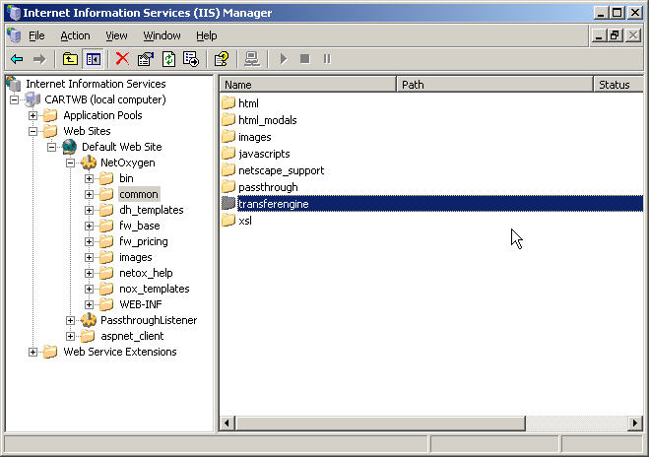
4 | Right-click on the Transferengine folder and select Properties. The transferengine Properties dialog opens. | 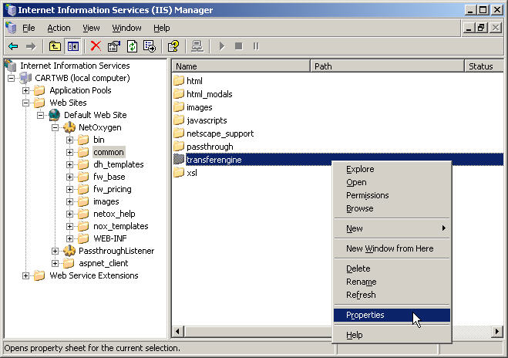
5 | Select Scripts and Executables from the Execute Permissions list box in the Directory tab.  Click OK to close the Transferengine Properties dialog. | 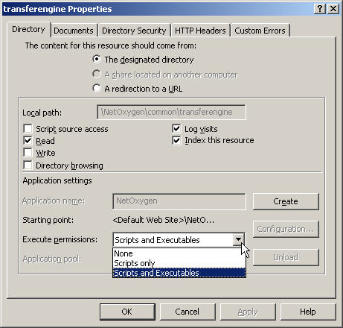

Procedure: Install the Soap Tool Kit
Step | Action | Screen Shot / Notes
1 | Locate the Soap tool Kit Directory on the \\PACLOSSTOR\STORAGE\LOS Server Build Files\ SOAP 3.0 SDK | Locate and execute the soapsdk.exe.  Accept all defaults.
2 | To check if properly installed, launch the IIS Services Manager Console.  Right-click on PassthroughListener and select Properties. The PassthroughListener Properties dialog opens. | 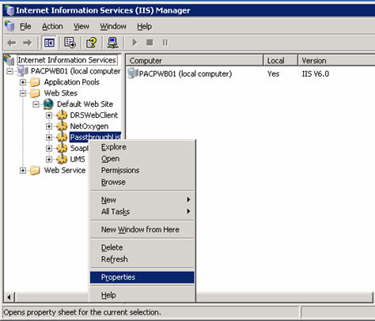
3 | Select Configuration.  The Application Configuration dialog opens. | 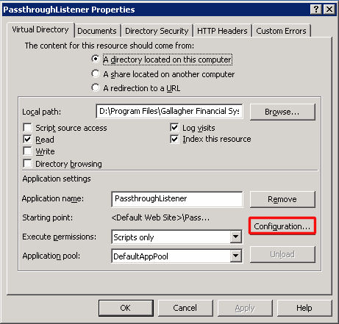
4 | Scroll down the Application extensions list to locate the .WSDL extension.  If the .WSDL extension is listed, you are good to go, click Cancel.  If the .WSDL extension is not listed, proceed to next step. | 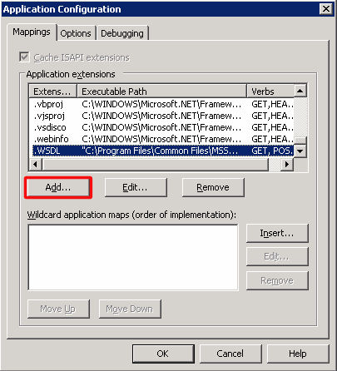
4a | If the .WSDL extension is not listed, click the Add button. The Add/ Edit Application Extension Mapping dialog opens. | 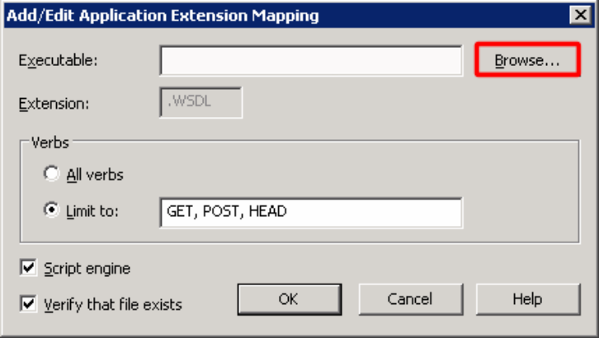
4b | Click Browse and navigate to the Binaries folder.  Select the SOAPIS30.dll file and click Open. | 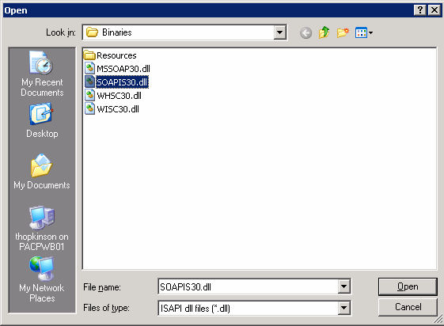
4c | The select file and path appear in the Executable field of the Add/ Edit Application Extension Mapping dialog.  If you have to manually configure the path verify the path is enclosed in double quotes in the Executable: field. (as in the example)  Match everything else to example on the right.  Click OK. | 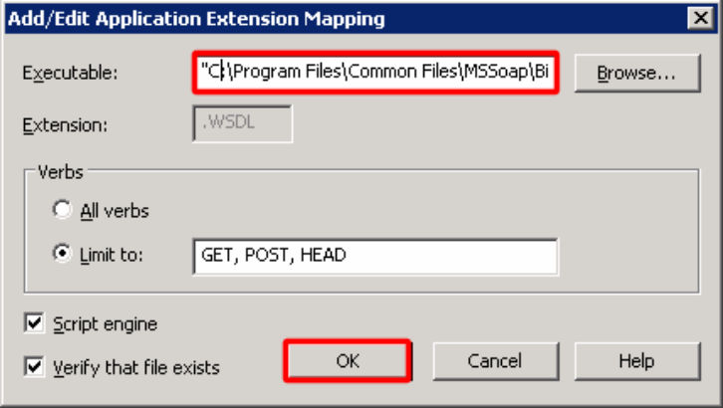

Procedure: Redirect the Web Server to point to the NetOxygen Directory
Step | Action | Screen Shot / Notes
1 | Right click on the Default Web Site and Select Properties. | 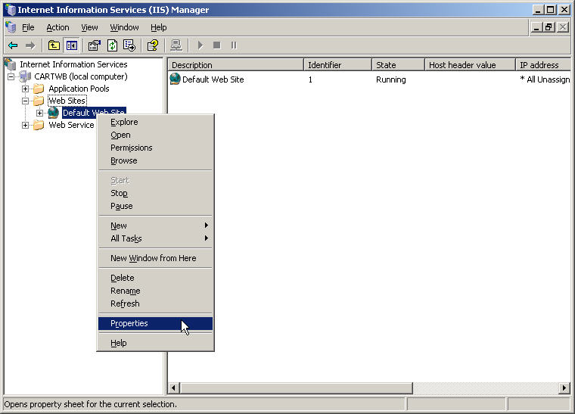
2 | Click on the Home Directory and select A redirection to a URL.  Enter /NetOxygen in the space provided. Check box A directory below URL entered. | 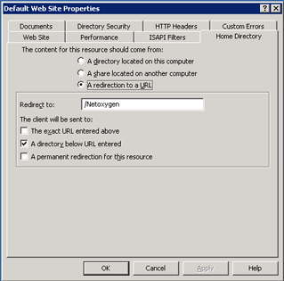
3 | Reboot the server at this time.

Procedure: Configure the Fremont Customized NetOxygen Application Server
Step | Action | Screen Shot (if applicable)
1 | Launch the Service MMC.
2 | Right-click on the NetOxygen Service and select Properties.
3 | Select the Logon tab and edit the Log on as: to use This Account. Use the example specified below.  [hostname]\Administrator  [correct password]
4 | Click the Apply and OK command buttons.
5 | Stop and Restart the NetOxygen Service.
6 | Locate the Req’d fonts in LOS Server build files\NOX Install and install the fonts per the readme file

Procedure: Edit GFXPassthroughListener.ini
Step | Action | Screen Shot / Notes
1 | Browse to %WinDir%\Temp using Windows Explorer. | For the transferengine to communicate with the NetOxygen application server, the IWAM_[MachineName]user must have read and write permissions on the %WinDir%\Temp folder (this is typically the c:\Windows\Temp folder or c:\Winnt\Temp folder).
2 | Browse to %WinDir% using Windows Explorer  Validate the GFXPassthroughListener.ini file has the following information. | [Passthrough Configuration]  ServerAddress=10.81.60.3  ListenerPath=/soaplistener/listener.asmx  [Timeouts]  ;Receive=3600000  ;Send=300000  ;Connect=60000  ;Resolve=0  ;Receive=3600000  ;Send=300000  ;Connect=60000  ;Resolve=0
3 | Save and Exit this file.

Procedure: Edit BASESESSIONMGRCFG.XML
Step | Action | Screen Shot (if applicable)
1 | Using Windows Explorer, browse to D:\..\Netoxygen\Interpreters.
2 | Open the BASESESSIONMGRCFG.XML file with Notepad.
3 | Validate the BASESESSIONMGRCFG.XMLfile has the following information | <?xml version="1.0"?>  <Configuration>  <Settings>  <DefaultTimeout>120</DefaultTimeout>  <ServerName>10.81.60.3</ServerName>  </Settings>  </Configuration>
6 | Save and Exit this file.

Procedure: Edit GFSMort.ini
Step | Action | Screen Shot (if applicable)
1 | Using Windows Explorer, browse to C:\Windows and edit the GFSMort.ini file with Notepad.
2 | Locate and Validate the following fields within the file. | Environment=PROD  Application=Millennium  ServerAddress=10.81.60.3  ListenerPath=/soaplistener/Listener.asmx  EnableSSL=0  SecurityPath=D:\Program Files\Gallagher Financial Systems\NetOxygen\Security
3 | Save and Exit this file.

Procedure: Edit GFXServer.ini
Step | Action | Comments
1 | Using Windows Explorer, browse to C:\Winnt and edit the GFXServer.ini file with Notepad.
2 | Locate and Validate the following fields within the file. | [Authentication Server]  DatabaseType=SQL SERVER ODBC  DSN=noa  UID=noa  PWD=[noa]  Environment=PROD  Application=NetOxygen  LocalServer=0  ServerAddress=10.81.60.3  ListenerPath=/Soaplistener/listener.asmx  EnableSSL=No  [GDB Options]  Owner=dbo
3 | Save and Exit file.

Procedure: Edit GFXGLOBALCONFIG.JS
Step | Action | Screen Shot / Notes
1 | Browse to D:\Program Files\  Gallagher Financial Systems\  NetOxygen\web_client\common\  javascripts\lib using Windows Explorer.  this.GFXSoapListenerURL =  ”http://<10.81.60.3>/  SoapListener/Listener.asmx”  this.GFXVirtual=”http://  <10.81.60.3>/  NetOxygen” | 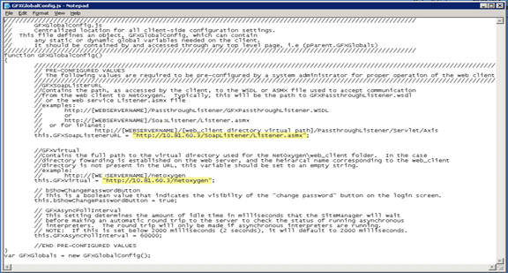

Procedure: Register the GFXPassthroughListener.dll file
Step | Action
1 | Browse to D:\...\Netoxygen\web_client\common\passthrough and right-click the GFXPassthroughListener.dll file and register comserver.

Procedure: Configure NetOxygen Printers
Step | Action | Screen Shot /Comments
1 | Browse to D:\..\Netoxygen.
2 | Locate and execute Install.exe. | 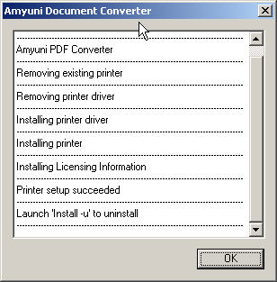
3 | Click OK.
4 | Open the Control Panel.
5 | Open Printers and Faxes. | Rename Amyuni PDF Converter to GFSPDFPrinter. Right click on the printer select properties click advanced, check that the driver is 2.50.
6 | Click on the icon to Add a printer to launch the Add Printer Wizard and click Next.
7 | Select Local printer attached to this computer. Deselect Automatically detect and install my Plug and Play printer.  Click Next.
8 | Select Create a new port:. Specify a Local Port. Click Next. | 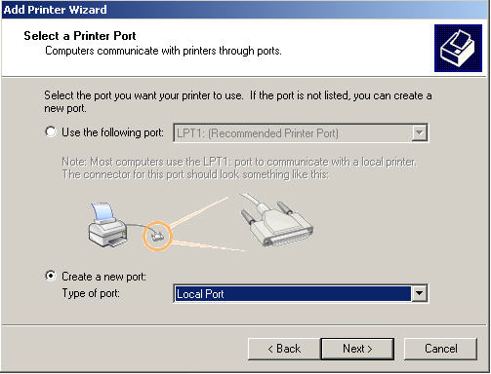
9 | When prompted for a port name, enter NetOxPCL and click OK. | 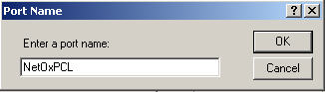
10 | From the Install Printer Software dialog, select HP then HP LaserJet 4000 PCL6, and click Next.  NOTE: Any Common print driver will work we have select the above as a standard. | 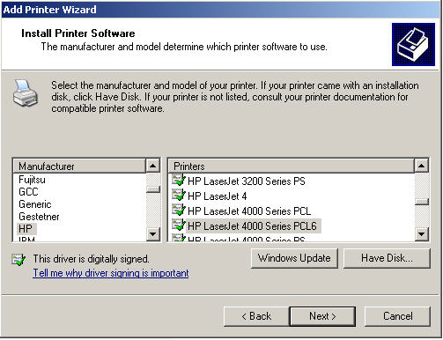
11 | If prompted to keep or replace existing drivers, accept the default option of Keep existing driver (recommended).  Click Next.
12 | At the Name Your Printer screen, name the printer NetOxPCL and do not select it as the default printer. Click Next.  Do not share the printer. Click Next.  Do not print a test page. Click Next. | 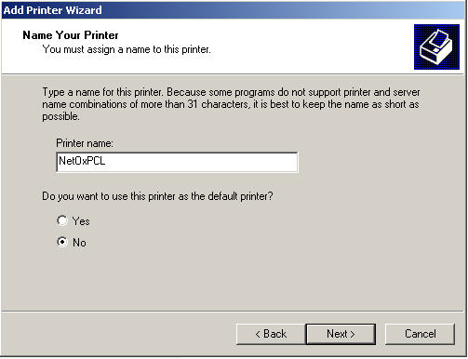
13 | At the summary screen, verify the Name and Port are specified as NetOxPCL. Click Finish. | 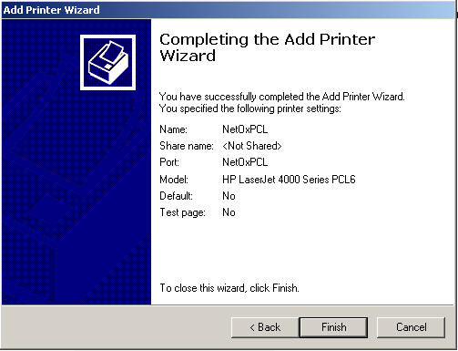

Procedure: Configure Authentication Studio
Step | Action | Screen Shot (if applicable)
1 | Browse to D:\..\Netoxygen.
2 | Locate and execute Authentication  Studio.exe. | Make sure IIS has been started and the NetOxygen service has been started
3 | When prompted for  User ID: admin  Password: QTpWZEI528dS  NOA Server: hsbcwbap01  Click OK. | 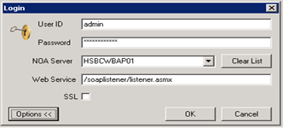
4 | With the NETOX database highlighted under NetOxygen in the left pane, Select the connection string click the Remove button in the right pane located under the Connection Strings section.  Now click the ADD button to display the Define Connection section. | 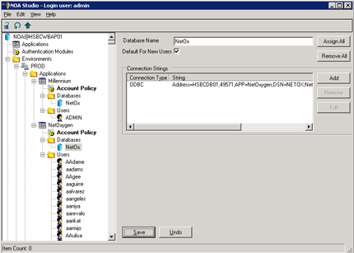
5 | Click the Select Data Source button to bring up the Select Data Source dialog. | 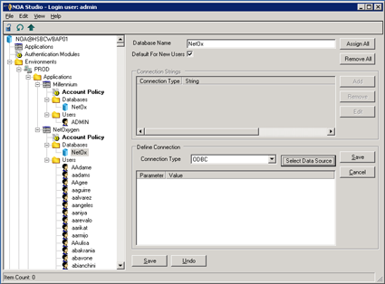
6 | Select the NETOX DSN from the Machine Data Source tab and click OK. | 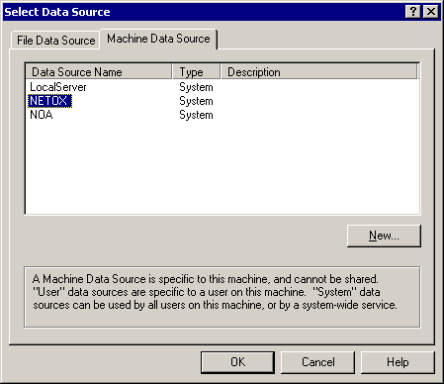
7 | At the SQL Server Login prompt, click the Options>> button to expand Options. Enter the correct Login ID and Password. Select NETOX as the default database. Verify the Application Name reads as NetOxygen. Verify the Workstation ID is the hostname of the server currently being configured.  Click OK. | 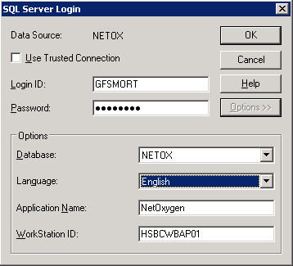
8 | Verify the parameters and values displayed under the Define Connection section are correct. Click the Save button to the right of the Select Data Source button.  Click Save to continue. | 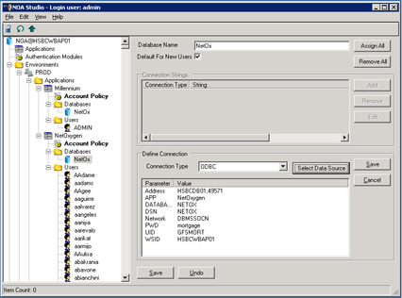
9 | Exit Authentication Studio by selecting File | Disconnect from the file menu to disconnect from the database.  Select File | Exit to exit Authentication Studio.

Procedure: Edit DCOM User List
Step | Action | Screen Shot (if applicable)
1 | Select Start | Run on the Windows menu bar to launch the Distributed COM Configuration Properties utility. The Run dialog appears.
2 | Enter DCOMCNFG.EXE in the Open field, and click the OK button. The Distributed COM Configuration Properties dialog opens. | 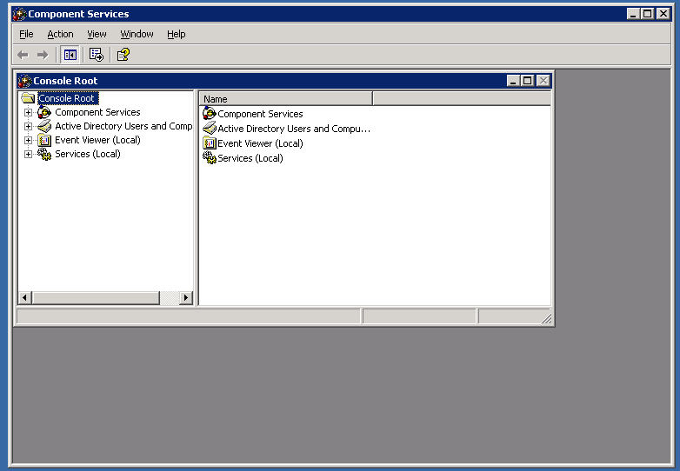
3 | Expand Computers. Then, Right-click on My Computer and select Properties. | 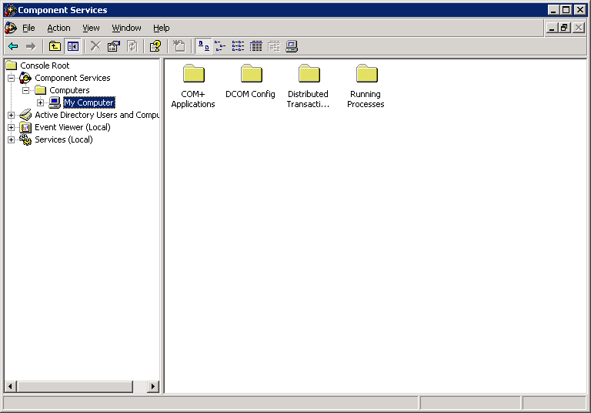
4 | The My Computer Properties dialog opens. Under Access Permission, select Edit Default. | 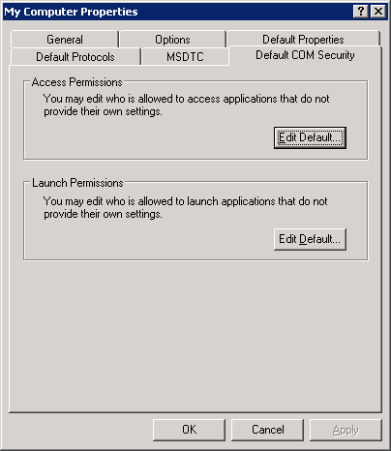
5 | Add the following users.  Default Access Permissions:  IWAM  IUSR  Administrators Group  INTERACTIVE Group  ASP.NET  SYSTEM Group  Default Launch Permissions:  IWAM  IUSR  Administrators Group  INTERACTIVE Group  SYSTEM Group
6 | Click OK and Exit.

Procedure: Edit the Encrypted Storage Manager
Step | Action | Screen Shot (if applicable)
1 | Browse to \\paclosmgt\LOS Server build files\Reg Files\Enycrpted Storage Manager\prod_ESMreghack.reg and double-click to install. | Stop IIS and Stop NetOxygen service then Start IIS and NetOxygen service  The Encrypted Storage Manager utility provides a way to store the GSSUserName setting in an encrypted form in your GFXSERVER.INI file. This utility allows you to bypass creating settings manually in your GFXSERVER.INI file.
2 | Launch the Encrypted Storage Manager utility from D:\..\Netoxygen\EncryptedStorageManager.exe. | Login with:  admin  QTpWZEI528dS
3 | Ensure Keys are present under the Section area. | 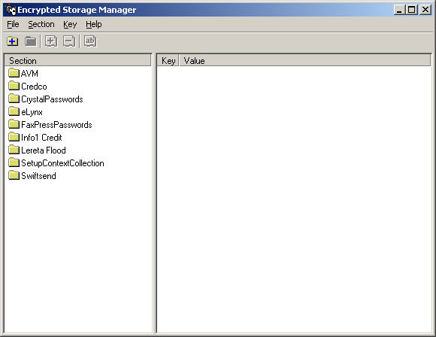
4 | Exit the Encrypted Storage Manager.

Procedure: Validate All-In-One Server Installation
Step | Action | Screen Shot (if applicable)
1 | Enter the following URL address in the Internet Explorer address bar.  http://hsbcwbap01/soaplistener/listener.asmx  Click on the Create Session button then Click the Invoke button.  A SOAP session is created displaying the GFSSessionManagerService Web Service page should be displayed. | 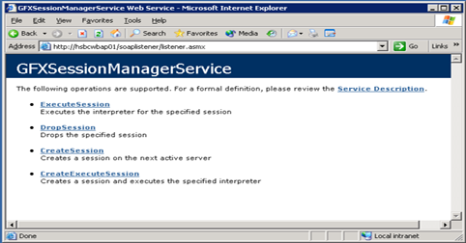  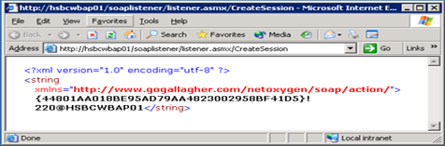
2 | Enter the following URL address in the Internet Explorer address bar.  http://hsbcwbap01/passthroughlistener/gfxpassthroughlistener.wsdl  The browser displays the contents of the GFXPassthroughListener.WSDL.  Browse to the bottom of the file to verify the <SOAP Address: Location> is set correctly to the All-In-One Server IP address.  Close and Exit Internet Explorer. | 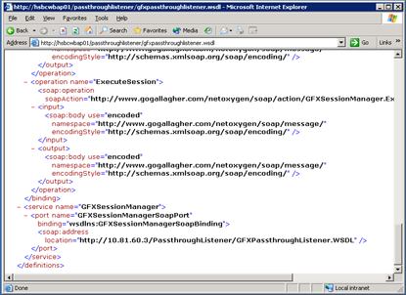
3 | Open up internet Explorer on your desktop and enter http://10.81.60.3 in the address bar.  The login screen displayed here is displayed. Showing the web components is properly serving pages. | 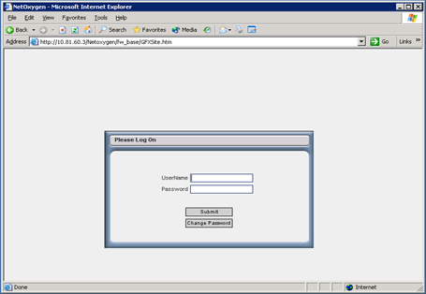
Appendix
Terms and Definitions
The following terms are referred to in this document:
Terms | Definitions
DSN Setup | A DSN must be present on the render server for each DSN used by a Crystal Reports document. The password for the user ID of the DSN must be set as outlined in the following steps.
Basic Password Support | In the [RenderConfig] section of the GFXSERVER.INI file, set the CrystalPassword setting to the password used by the DSN for Crystal Reports. If you want to encrypt Crystal Reports passwords, ignore this step and continue with Encrypted Password Support.
Encrypted Password Support | Use the EncryptedStorageManager utility to add a CrystalPasswords section, if not present. In the CrystalPasswords section, set up keys, where each key name is a user ID and the key value is the associated password. Make sure that the location of this information set by the utility is the same as the .INI file setting for the LoginContext. This setting allows reports to use different DSN user IDs and passwords, although only one DSN per report is currently supported.  Make sure that the location of this information (password file or registry) corresponds to the correct EncryptedStorageLocation setting in the [LoginContext] section.
Default Password Behavior | By default, the password will be retrieved from the GFXSERVER.INI file. If this location is not correct, remove the CrystalPasswords setting in the [Render Config] section from the GFXSERVER.INI file and the encrypted storage location will be used instead. If neither location contains a password, the user will be prompted for the DSN password.
Required .INI Setting | In the [RenderConfig] section of the GFXSERVER.INI file, set the CrystalReportPath setting to the directory where the Crystal Reports files are located.
Optional .INI Setting | In the [RenderConfig] section of the GFXSERVER.INI file, set the CrystalPassword setting to the password used for all Crystal Reports DSNs on the server.  Continue the installation with the Generating Web Page Files section

